

**SSR COLLEGE OF ARTS, COMMERCE & SCIENCE SILVASSA**

**(Affiliated to Savitribai Phule Pune University, NAAC Accredited with B+ Grade)**

**Submitted to the partial fulfillment of**

T.Y BBA(CA)

2022-2023

Project Work

“FACE RECOGNITION ATTENDANCE SYSTEM”

Guided By: Submitted By:

Mr. VISHAL LANGALIYA AMAN MADAN CHOUDHARY



**SSR COLLEGE OF ARTS, COMMERCE & SCIENCE SILVASSA**

**(Affiliated to Savitribai Phule Pune University, NAAC Accredited with B+ Grade)**

**Sayli, Silvassa-396230, D&N.H**

Department of Computer Application

**CERTIFICATE**

This is to certify that Mr. **AMAN MADAN CHOUDHARY** of T.Y.B.B.A [Computer Application] has successfully completed his/her project work on the topic **FACE RECONGITION ATTENDANCE SYSTEM** in the academic year 2021-2022.

### Project Guide H.O. D

**Internal Examiner External Examiner**

### Seal of the College

**ACKNOWLEDGEMENT**

It is a great pleasure to acknowledge and express our deep sense of gratitude to **SSR College of ARTS COMMERCE & SCIENCE** for providing me the infrastructure to carry out the project.

I extremely grateful and remain indebted to our guide by **Mr. VISHAL LANGALIYA** for being a source of inspiration and for his constant support in the Design, Implementation and Evaluation of the project. I am thankful to him, for his constant constructive criticism and valuable suggestions, which benefited me a lot while developing the project on **FACE RECONGITION ATTENDANCE SYSTEM**. He has been a constant source of inspiration and motivation which helped us to complete this project successfully.

I also extend my gratitude to our teachers and other staff members of the department for their constant support for completing this project.

I would like to thank Savitribai Phule Pune University for providing us an opportunity to apply our knowledge and skills in a practical environment as a part of curriculum for

### T.Y.B.B.A [Computer Application].

Lastly but significantly, we express sincere gratitude to all our friends and fellow students at SSR College for their help and timely advice on various occasions during this project.

**ABSTRACT**

This project involves building an attendance system which utilizes Facial Recognition to mark the presence, time-in, and time-out of employees or Students. It covers areas such as facial detection, alignment, and recognition, along with the development of a web application to cater to various use cases of the system such as registration of new employees, addition of photos to the training dataset, viewing attendance reports, etc. This project intends to serve as an efficient substitute for traditional manual attendance systems. It can be used in corporate offices, schools, and organizations where security is essential.

**Technologies used**

* Microsoft visual studio (Python ,HTML,CSS, , Java script, PHP)
* MYSQL server(Xampp).
* Flask web framework.

**Server Requirements**

* PHP version 8.1 or newer.
* MySQL (6.1+) MySQL (6.1+),MySQL.
* Mb string PHP Extension.
* Tokenizer PHP Extension.

**Important Package Requirements**

* Import cv2 [last version import OpenCV]
* Import os
* From flask import Flask, request,render_template
* From datetime import date
* From datetime import datetime
* Import numpy as np
* Import sklearn.neighbors import KNeighborsClassifier
* Import pandas as pd

**INDEX**

|  |  |  |
| --- | --- | --- |
| **S.NO.** | **TOPIC** | **PAGE.NO** |
| **1.** | **INTRODUCTION**  1.Introduction to System 2. Scope Of the System | **6 - 8** |
| **2.** | **TOOL INFORMATION**   1. Front End Tool 2. Back End Tool | **9 - 12** |
| **3.** | **ANALYSIS**   1. Feasibility Study 2. Fact Finding Technique | **13 - 16** |
| **4.** | **SOFTWARE AND HARDWARE REQUIREMENT** | **17 - 18** |
| **5.** | **SYSTEM DESIGN**   1. DFD 2. USE ER DIAGRAM 3. DATA DICTIONARY | **19 - 27** |
| **6.** | **INPUT AND OUPUT DESIGN**  1.Screenshots | **28 - 35** |
| **7.** | **ADVANTAGES AND LIMITATIONS** | **36 - 37** |
| **8.** | **FUTURE ENHANCEMENT** | **38 - 39** |
| **9.** | **BIBLIOGRAPHY** | **40 - 41** |

# INTRODUCTION

## INTRODUCTION TO SYSTEM

This project aims to automate the traditional attendance system where the attendance is marked manually. It also enables an organization to maintain its records like in-time, out time, break time, day and attendance digitally. Digitalization of the system would also help in better visualization of the data using graphs to display the no. of employees present today, total work hours of each employee and their break time. Its added features serve as an efficient upgrade and replacement over the traditional attendance system.

# Software Requirements Specification - SRS

We have 2 types of users of the system.

1. Employee
2. Admin

**Following functionalities can be performed by the admin:**

* Login
* Register new employees to the system
* Add employee **photos 50 different frame capture** and store static/face to the training data set
* Train the model
* View attendance report of all employees. Attendance can be filtered by date or employee.
* Mark his/her time-in and time-out by scanning their face
* View attendance report of self

## SCOPE OF THE SYSTEM

Facial recognition is becoming more prominent in our society. It has made major progress in the field of security. It is a very effective tool that can help low enforcers to recognize criminals and software companies are leveraging the technology to help users access the technology. This technology can be further developed to be used in other avenues such as ATMs, accessing confidential files, or other sensitive materials.

This project servers as a foundation for future projects based on facial detection and recognition. This project also convers web development and database management with a user-friendly UI. Using this system any corporate offices, school and organization can replace their traditional way of maintaining attendance of the employees and can also generate their availability(presence) report throughout the month.

**Admin have the authority to control and modify the database.**

Scopes that have been considered during the development of the project are as follows:

1. User Friendly
2. Menu Driven Interface
3. Easily Upgradable
4. Data Retrieval, Updating, Insertion, Deletion
5. System Consistency
6. Allowing Keyboard Inputs
7. Taking care of Computing time
8. Easy Database Handling
9. Be easy to operate
10. Have a good user interface
11. It satisfy the user requirement

# TOOL INFORMATION

## FRONT END TOOL

**Python :** Python is a computer programming language often used to build websites and software, automate tasks, and conduct data analysis. Python is a general-purpose language, meaning it can be used to create a variety of different programs and isn’t specialized for any specific problems. A survey conducted by industry analyst firm RedMonk found that it was the second-most popular programming language among developers in 2021

**HTML :** HTML is an acronym which stands for **Hyper Text Markup Language** which is used for creating web pages and web applications. Let's see what is meant by Hypertext Markup Language, and Web page.

**Hyper Text:**  Hypertext simply means "Text within Text." A text has a link within it, is a hypertext. Whenever you click on a link which brings you to a new webpage, you have clicked on a hypertext. Hypertext is a way to link two or more web pages (HTML documents) with each other.

**Markup language:** A markup language is a computer language that is used to apply layout and formatting conventions to a text document. Markup language makes text more interactive and dynamic. It can turn text into images, tables, links, etc.

**Web Page:** A web page is a document which is commonly written in HTML and translated by a web browser. A web page can be identified by entering an URL. A Web page can be of the static or dynamic type**. With the help of HTML only, we can create static web pages**.

**CSS :** CSS stands for Cascading Style Sheets. It is a style sheet language which is used to describe the look and formatting of a document written in markup language. It provides an additional feature to HTML. It is generally used with HTML to change the style of web pages and user interfaces. It can also be used with any kind of XML documents including plain XML, SVG and XUL. CSS is used along with HTML and JavaScript in most websites to create user interfaces for web applications and user interfaces for many mobile applications. CSS save s a lot of Time .CSS style definitions are saved in external CSS files so it is possible to change the entire website by changing just one file.

# What is a responsive website?

* A website is called responsive website which can automatically adjust itself to look good on all devices, from smart phones to desktops etc.

## BACK END TOOL

**Flask : Flask**  is a micro [web framework](https://en.wikipedia.org/wiki/Web_framework) written in [Python](https://en.wikipedia.org/wiki/Python_(programming_language)). It is classified as a [microframework](https://en.wikipedia.org/wiki/Microframework) because it does not require particular tools or libraries.[[2]](https://en.wikipedia.org/wiki/Flask_(web_framework)#cite_note-2) It has no [database](https://en.wikipedia.org/wiki/Database) abstraction layer, form validation, or any other components where pre-existing third-party libraries provide common functions. However, Flask supports extensions that can add application features as if they were implemented in Flask itself. Extensions exist for [object-relational mappers](https://en.wikipedia.org/wiki/Object%E2%80%93relational_mapping), form validation, upload handling, various open authentication technologies and several common framework related tools.

**PHP**

PHP is stands for hypertext Pre-processor an open-source, interpreted, and object-oriented scripting language that can be executed at the server-side. PHP is well suited for web development. Therefore, it is used to develop web applications (an application that executes on the server and generates the dynamic page.).

* PHP is faster than other scripting languages, for example, ASP and JSP.
* PHP can be embedded into HTML.
* PHP is simple and easy to learn language.

**MYSQL**

MySQL is the most popular Open-Source Relational SQL database management system. MySQL is one of the best RDBMS being used for developing web-based software applications.

**Database**

A database is a separate application that stores a collection of data. Each database has one or more distinct APIs for creating, accessing, managing, searching, and replicating the data it holds. Other kinds of data stores can also be used, such as files on the file system or large hash tables in memory but data fetching and writing would not be so fast and easy with those type of systems.

# ANALYSIS

## FEASIBILITY STUDY

The objective of the feasibility study is to solve the problem and to acquire the ease of its scope. Feasibility means practicable. The feasibility analysis focuses on the fact that whether the project will be acceptable or not. If the feasibility analysis confirms that the project is feasible, it can be taken up for development. In preliminary investigation we found that project feasible.

### Types of Feasibility

1. **Operational Feasibility**

Operational feasibility makes a mark on whether the project can be done with full requirements that the clients provide or not. Includes following:

* 1. Analyzing all requirements.
  2. Can be done in given period of time or not.

### Technical Feasibility

Technical feasibility takes into account the technical aspect of the project includes the following:

* 1. Whether the project can be implemented with the existing technology or not.
  2. Whether the project technically compatible or not.

### Economic Feasibility

It determines whether the requirement software is capable of generating financial gains for an organization. It involves the cost incurred on the software development team estimated cost of hardware and cost of performing feasibility study and so on. Studying the feasibility of the project, the project can be implemented with the given period of time and with the existing or specified technology. Hence,we can conclude that this project is feasible.

## FACT FINDING TECHNIQUE

To study a system the analyst needs to do collect facts and all relevant information. The facts when expressed in quantitative form are termed as data. The success of any project is dependent upon the accuracy of available data. Accurate information can be collected with help of certain methods/techniques. These specific methods for finding information of the system are termed as fact finding technique Interview, Questionnaire, Record view and Observation are the different fact gathering techniques used by the analyst. The analyst may use more than one technique for investigation.

### INTERVIEW :

This method is used to collect the information from the groups of individuals. Analyst selects the people who are related with the system for the interview. In this method the analyst sits face to face with the people and records their responses. The interviewer must plan in advance the type of questions he/she is going to ask and should be ready to answer any type of questions. He should also choose a suitable place and time which will be comfortable for the respondent.

The information collected is quite accurate and reliable as the interviewer can clear and cross check the doubts there itself. This method also helps gap the areas of misunderstandings and help to discuss about the future problems. Structured interview is more formal where fixed questions are asked, and specific information is collected whereas unstructured interview is more or less like a casual conversation where in depth areas topics are covered and other information apart from the topic may also be obtained.

### RECORD VIEW :

The information related to the system is published in the sources like newspapers, magazines, journals, documents, etc. This record review helps the analyst to get the valuable information about the system and the organization.

### OBSERVATION :

Unlike the other fact gathering techniques, in this method the analyst himself visits the organization, he observes and understands the flow of the documents, working of the existing system, the users of the system etc. For this method to be adopted it takes an analyst to perform this job as he knows which points should be noticed and highlighted. The analyst may observe the unwanted things as well as simply cause delay in the development of the new system.

### QUESTIONNAIRES :

Questionnaires are a research instrument that can be applied to fact finding in system development projects. It is an economical way of gathering data from large number of people.

# SOFTWARE AND HARDWARE REQUIREMENTS

## SOFTWARE REQUIREMENT

**Requirements**

* Python version 3.10.7
* Flask version 2.2.2
* Werkzeug version 2.2.2
* PHP version 8.1 or newer.
* MySQL (6.1+) MySQL (6.1+), MySQL.
* Open SSL PHP Extension.
* Mb string PHP Extension.

## HARDWARE REQUIREMENT

To run the application software of the system in the computer, the minimum hardware configuration required is as below:

* **Important facial recognition HD Camera**
* 1.7 GHz Pentium processor or other compatible
* Intel chipset motherboard
* 2GB MB DDR-RAM
* Color Monitor or LCD
* Keyboard
* Mouse
* Windows 10 +

# SYSTEM DESIGN

## DATA FLOW DIAGRAM

The data flow diagram is pictorial or graphical representation of the system study. The data flow covers all the processes and data storage area, which takes place during any transaction in the system. The data flow diagrams are functionally into context level, zero level diagrams.

1. **Process:** Here flow of data is transformed
2. **External Entity:** A source or destination of data, which is external to the system.
3. **A Data Flow:** It is a packet of data. It may be in the form of document, letter, etc.

d. **Data storage:** Any storage of data but with no reference to physical memory of storing.

### ZERO LEVEL DATA FLOW DIAGRAM

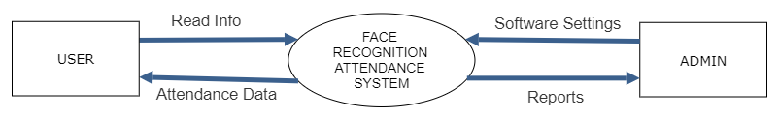

**FIRST LEVEL DATA FLOW DIAGRAM**

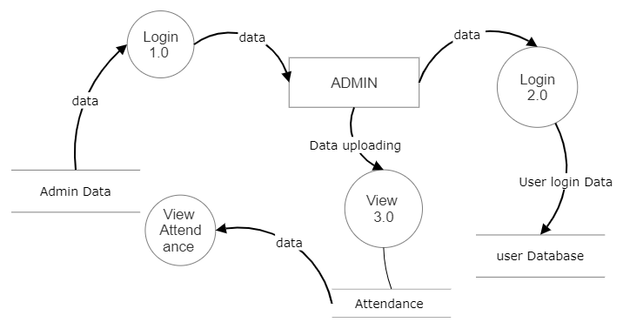

**SECOND LEVEL DATA FLOW DIAGRAM**

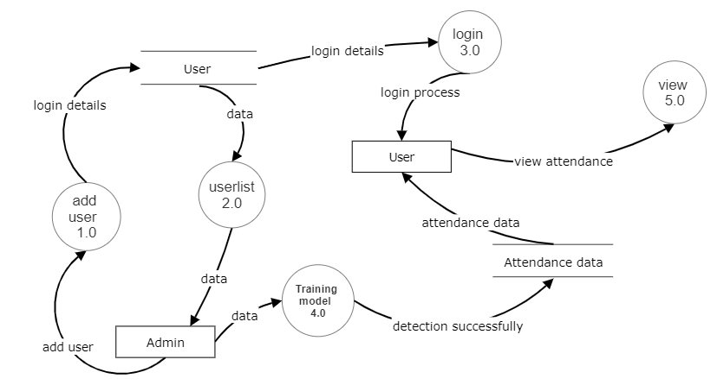

## USE ER DIAGRAM

A use case diagram is a graphical depiction of a user’s possible interactions with a system. A use case diagram shows various use cases and different types of users the system has and will often be accompanied by other types of diagrams as well.

The use cases are represented by either circles or ellipses. It specifies the expected behavior and not the exact method of making it happen.

A use case diagram is usually simple. It does not show the detail of the use cases:

* It only summarizes some of the relationships between use cases, actors, and systems.
* It does not show the order in which steps are performed to achieve the goals of each use case.

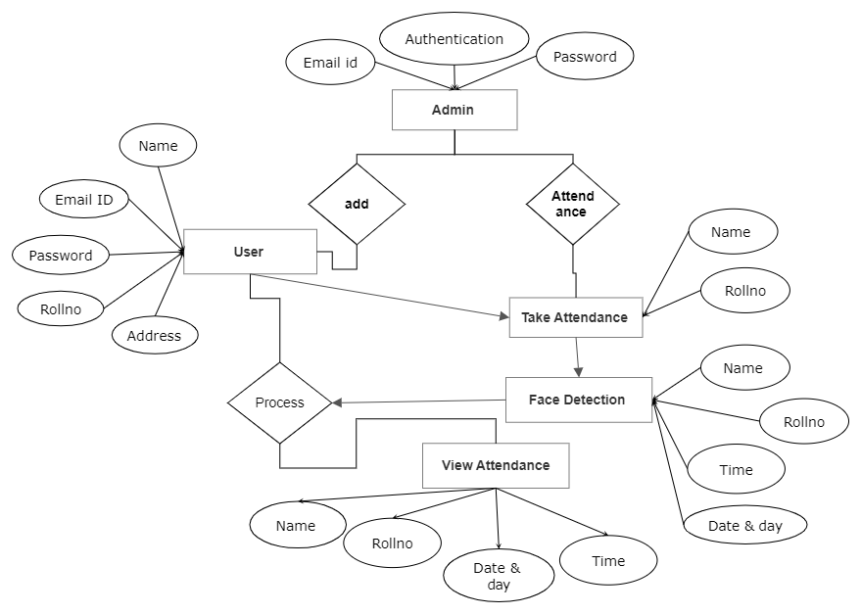

## DATA DICTIONARY

Data dictionary is a repository that contains description of all the data objects consumed by the webapp application. It is a list of names used by the system alphabetically.

As well as the name, the dictionary should include a description of the named entity and, if the name represents of a composite object, there may be description of the name entity.

Other information such as the date of creation, creator and the representation. Entity may also include depending on the type of module, which is being developed.

The data dictionary software can check for name uniqueness and tell requirements analyst duplication.

It serves as store of organizational information which can link analysis, design, implementation and evolution. As the system is developed, information is taken to inform the development. New information is added in it. All information about entity is in one place.

### DATA REPORTS :

TABLE: **ADMIN LOGIN**

|  |  |  |  |  |
| --- | --- | --- | --- | --- |
| Field Name | Datatype | Size | Constraints | Description |
| Id | int | 255 | Primary Key | Stores id |
| Name | varchar | 255 | Not Null | Stores name |
| Email | varchar | 255 | Not Null | Stores email id |
| Password | varchar | 255 | Not Null | Stores password |
| User type | varchar | 255 | Not Null | Stores user |
| gender | varchar | 255 | Not Null | Stores gender |
| moblieno | bigint | 10 | Not Null | Stores mobile |
| adds | varchar | 500 | Not Null | Stores Address |

TABLE: **USER LOGIN**

|  |  |  |  |  |
| --- | --- | --- | --- | --- |
| Field Name | Datatype | Size | Constraints | Description |
| Id | Int | 255 | Primary Key | Stores id |
| Name | varchar | 255 | Not Null | Stores name |
| Email | varchar | 255 | Not Null | Stores email id |
| Password | varchar | 255 | Not Null | Stores password |
| User type | varchar | 255 | Not Null | Stores user |
| gender | varchar | 255 | Not Null | Stores gender |
| rollno | varchar | 255 | Not Null | Stores rollno |
| moblieno | bigint | 10 | Not Null | Stores mobileno |
| adds | varchar | 500 | Not Null | Stores Address |

TABLE: **DATA**

|  |  |  |  |  |
| --- | --- | --- | --- | --- |
| Field Name | Datatype | Size | Constraints | Description |
| Id | Int | 100 | PrimaryKey | Stores id |
| Name | varchar | 500 | Not Null | Stores Name |
| Roll | varchar | 10 | Not Null | Store mobile no |
| time | varchar | 50 | Not Null | Stores email id |
| date | varchar | 100 | Not Null | Stores subject |

|  |  |  |  |
| --- | --- | --- | --- |
| Name | Rollo | Time | DD/MM/YYYY |
| Varchar(30) | Int(5) | Int(20) | Varchar(16) |

TABLE: **CSV**

TABLE: **INQUIRY FORM**

|  |  |  |  |  |
| --- | --- | --- | --- | --- |
| Field Name | Datatype | Size | Constraints | Description |
| ID | Int | 100 | Primary Key | Stores |
| name | varchar | 200 | Not Null | Stores Name |
| Email | text | - | Not Null | Stores Email id |
| Number | text | - | Not Null | Stores Number |
| Subject | text | - | Not Null | Stores Subject |
| Message | varchar | 2083 | Not Null | Stores Message |
| Status | text | - | Not Null | Stores Status |
| Rollno | varchar | 20 | Not Null | Stores Rollno |
|  |  |  |  |  |
|  |  |  |  |  |
|  |  |  |  |  |

**6. INPUT AND OUTPUT DESIGN**

## SCREENSHOTS

ADMIN LOGIN PAGE:

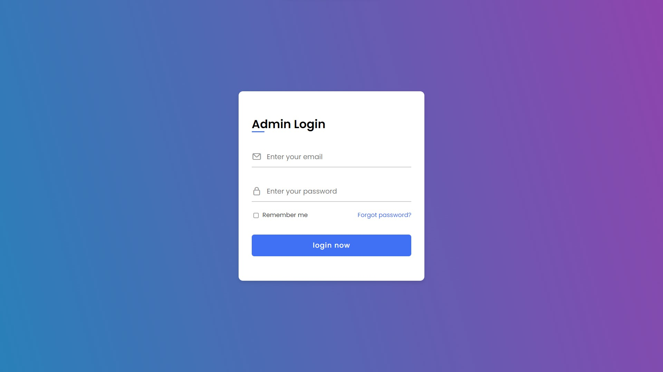

ADMIN DASHBOARD PAGE:

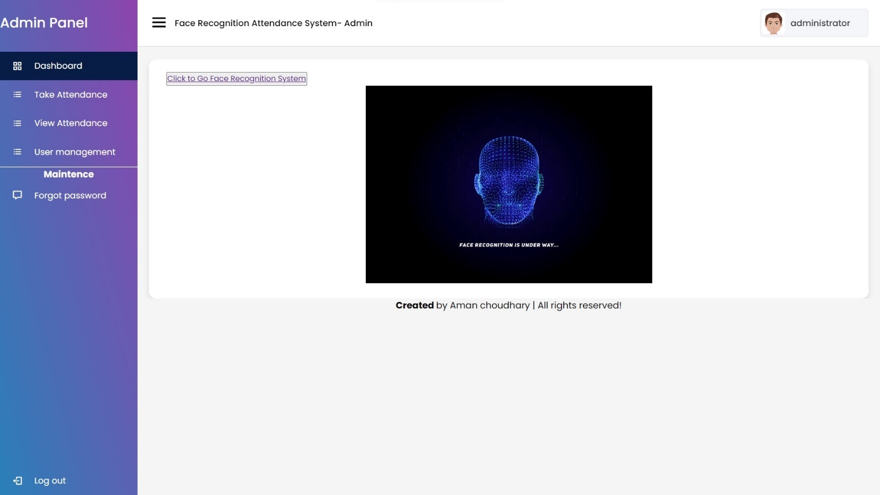

ADMIN TAKE ATTENDANCE PAGE :

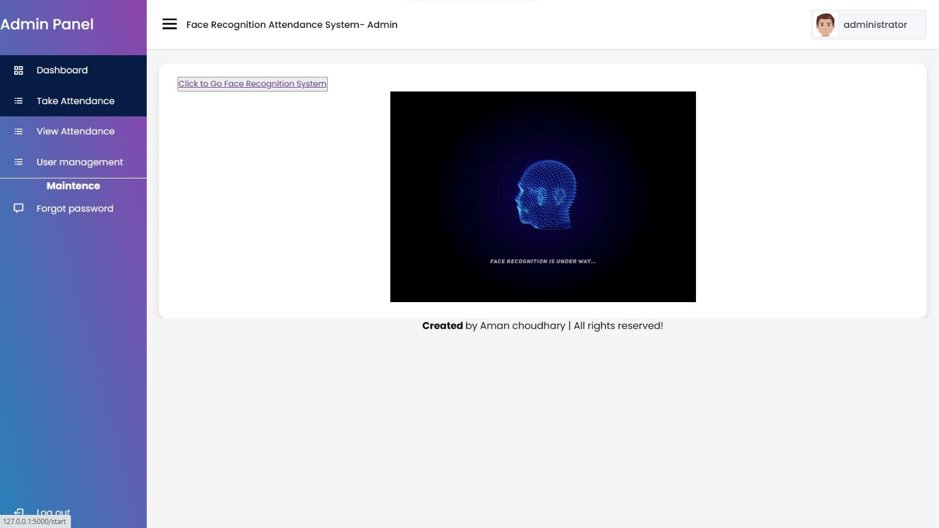

ADMIN CAN ADD THE USER PAGE :

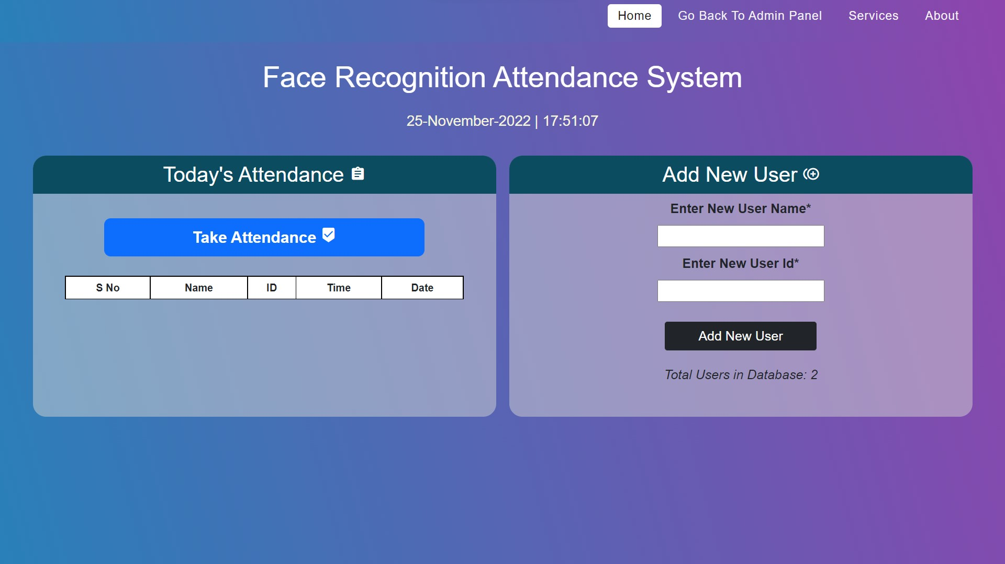

START IMAGE CAPTURED 50 :

START IMAGE CAPTURED 50 :

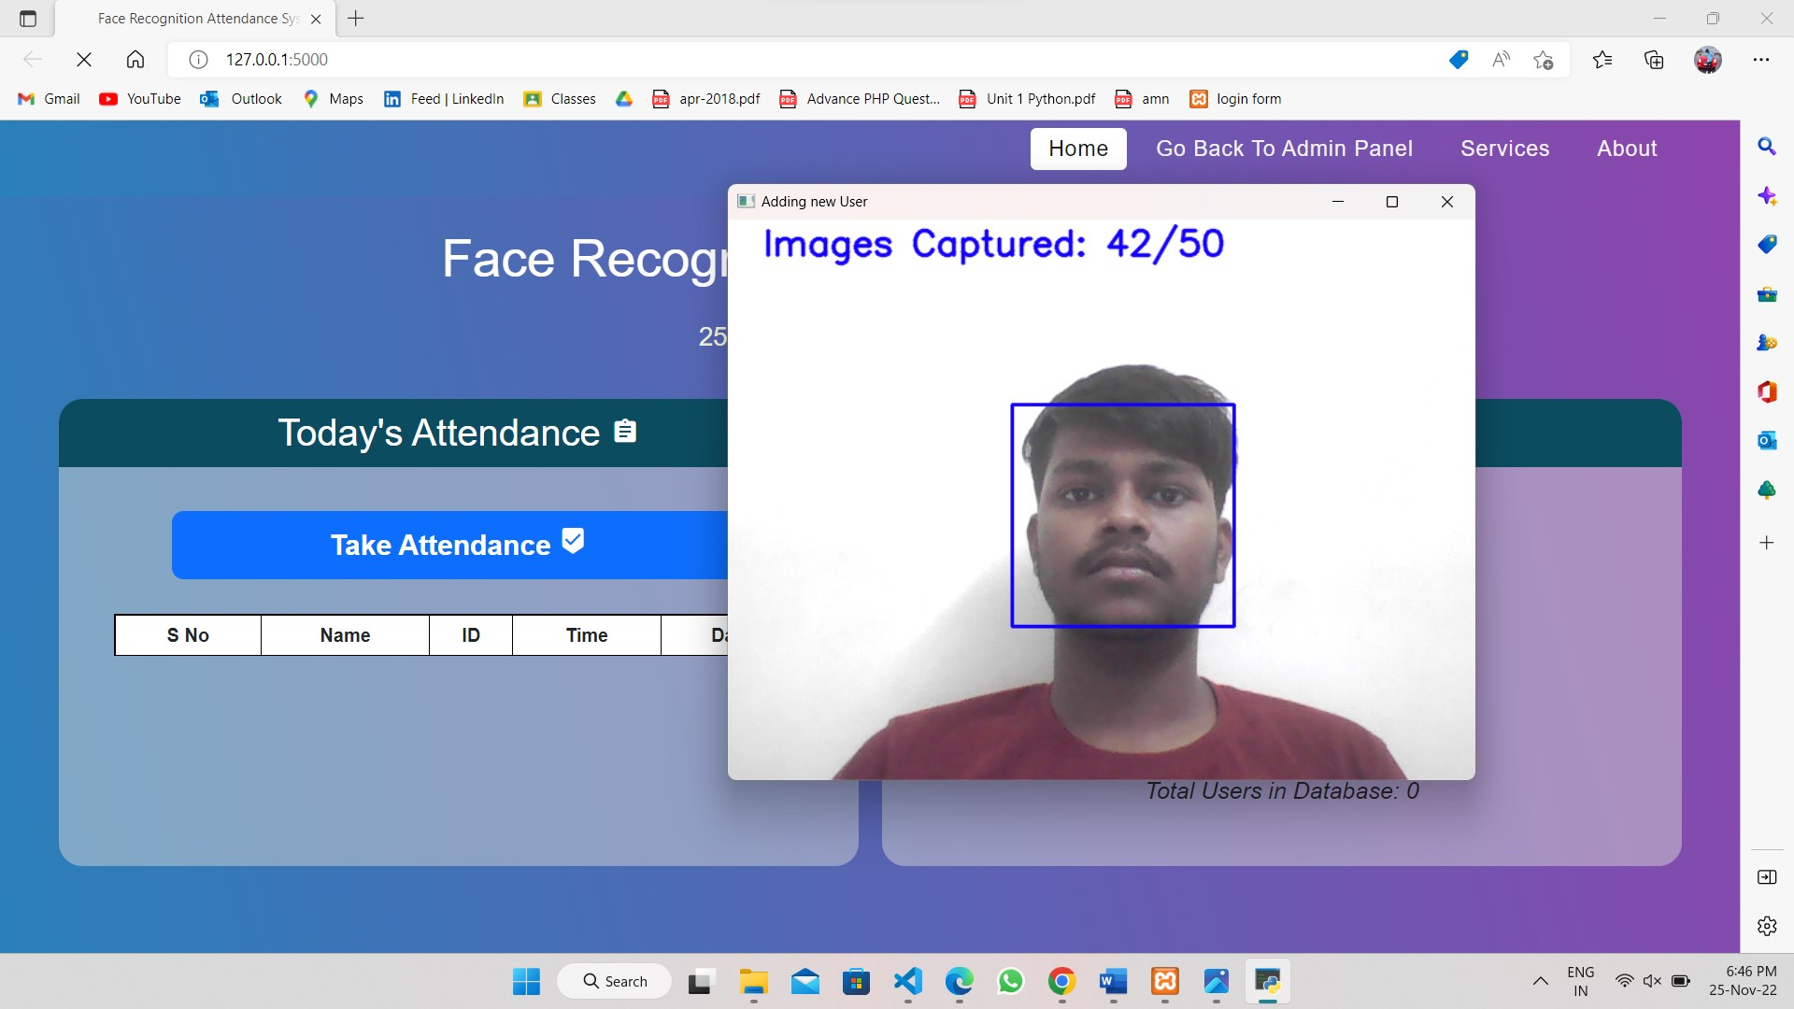

AUTOMATIC SAVE IN STATIC/FACE/USERNAME :

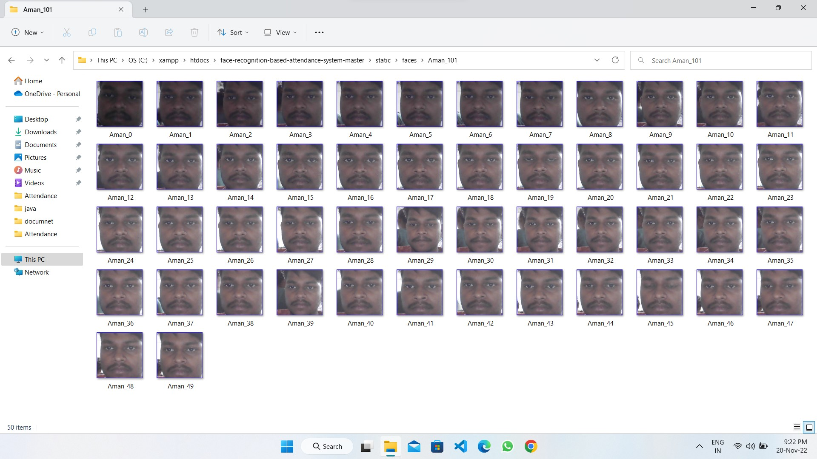

TAKE ATTENDANCE POPUP ATTENDANCE OPEN CAMERA AUTOMATIC :

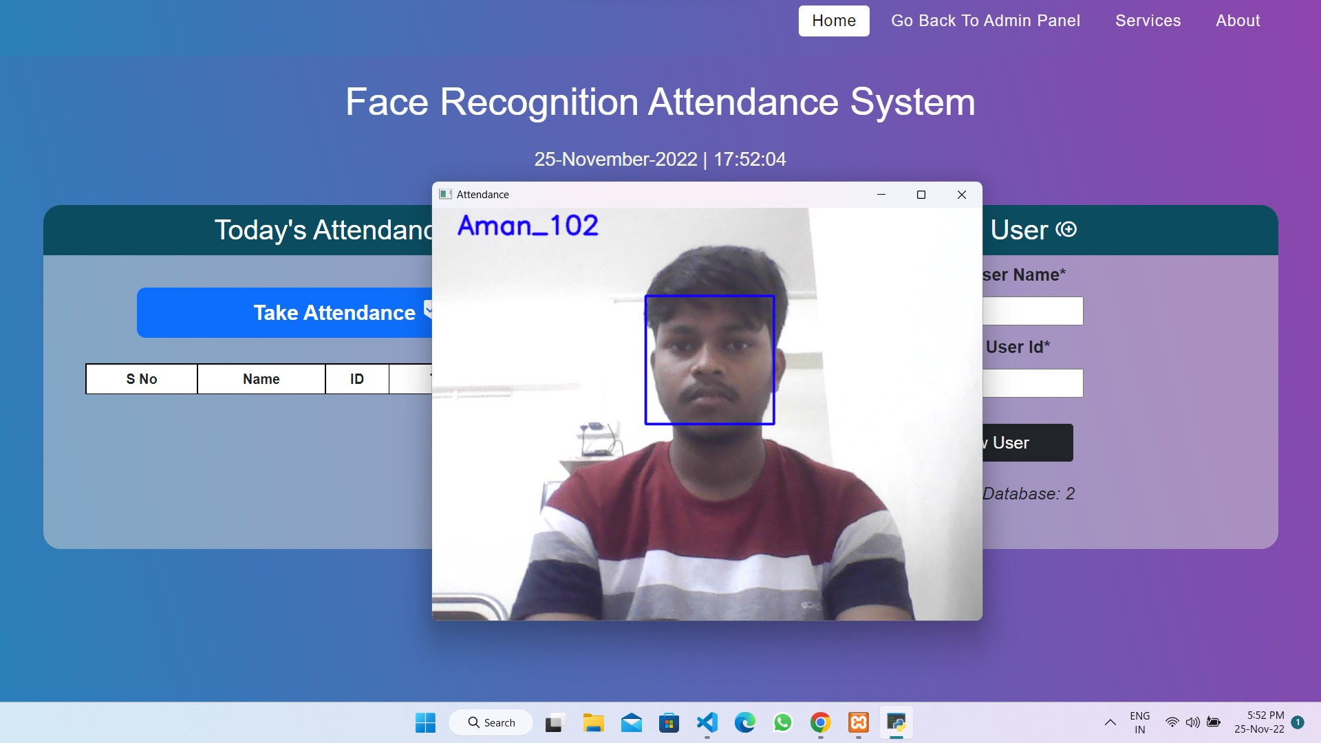

SEE ATTENDANCE SHOWING :

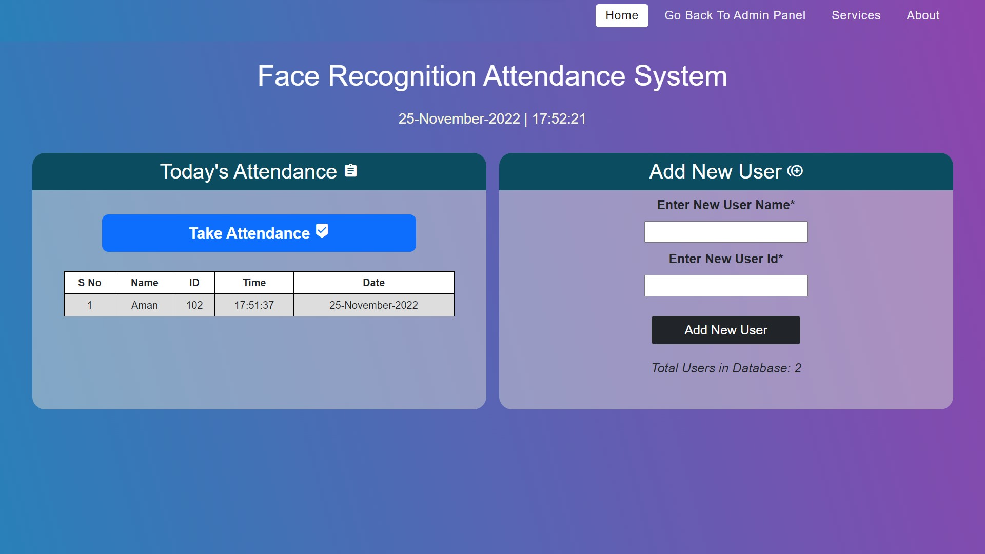

UPLOAD INTO DATABASE BY MANUALLY:

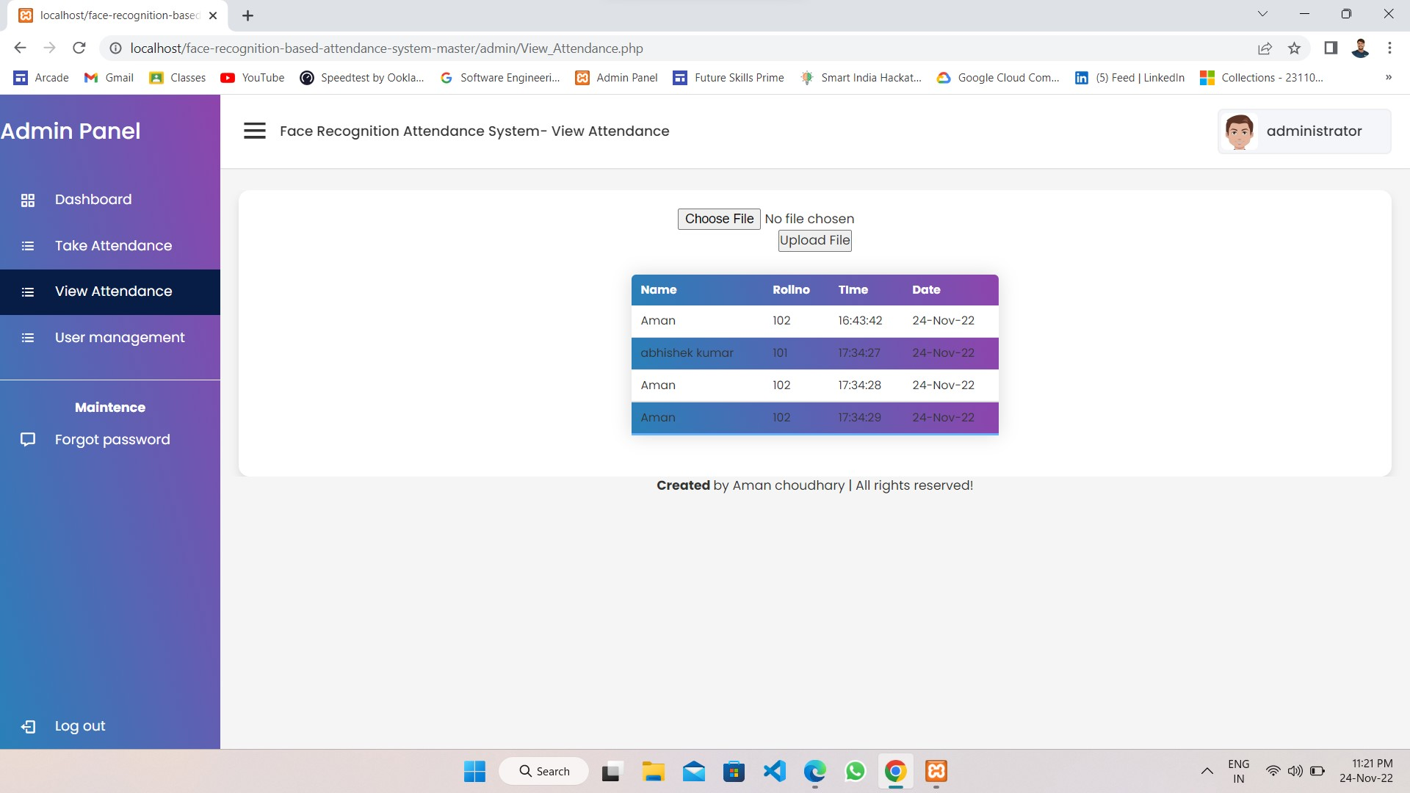

VIEW USER REGISTERED:

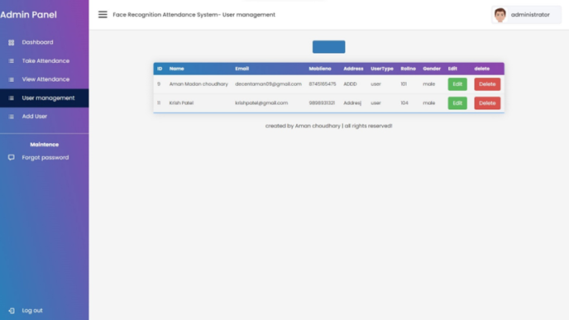

UPDATE & DELETE:

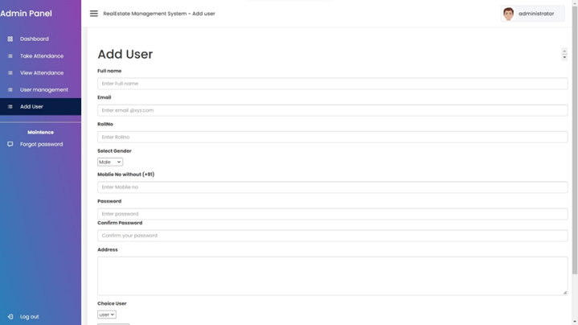

USER LOGIN PAGE :

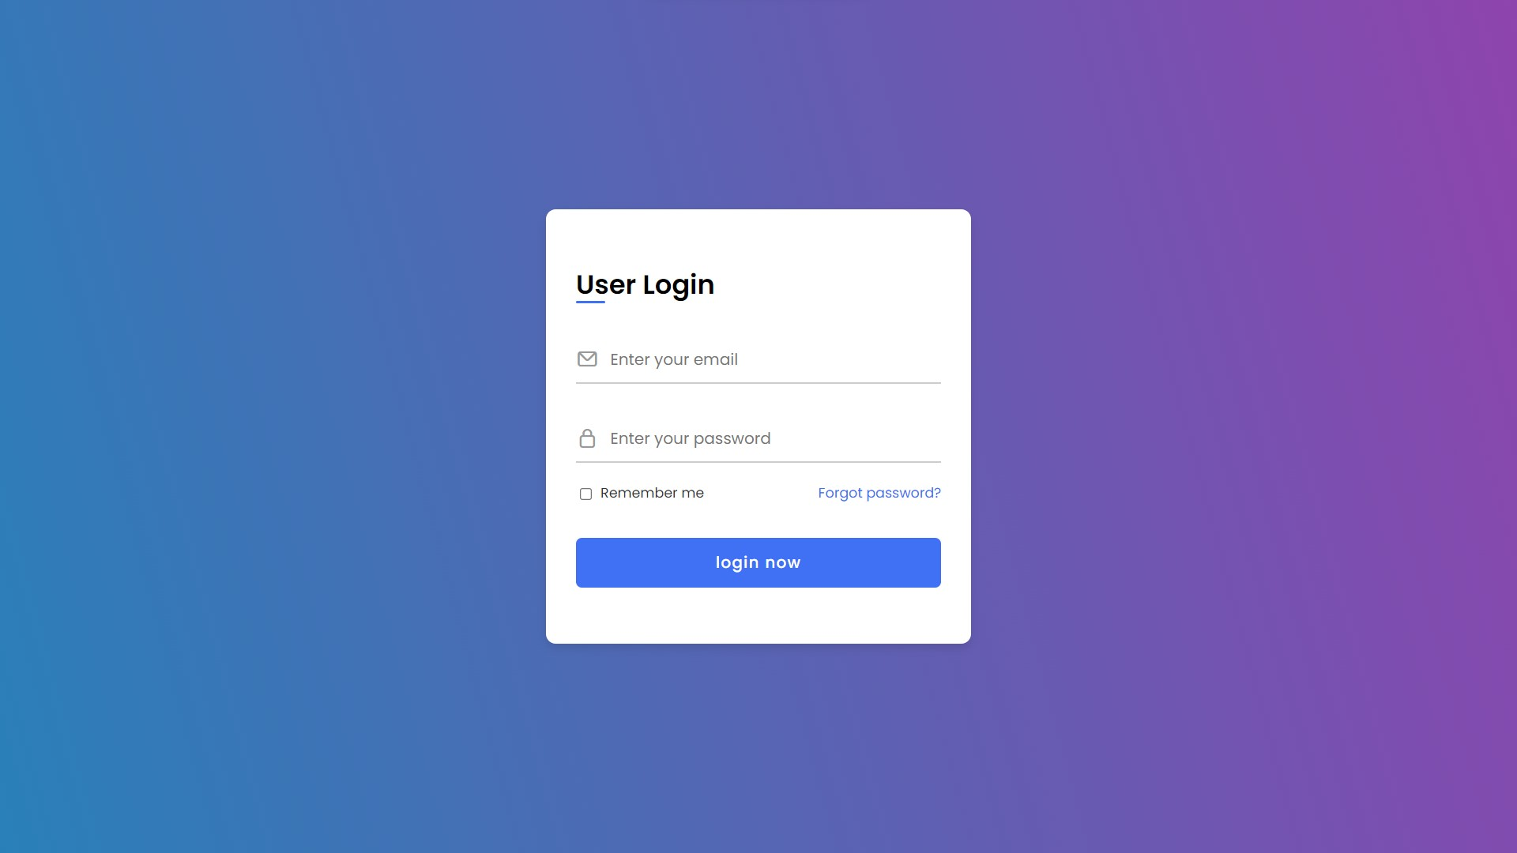

CHECK YOUR ATTENDANCE BY NAME OR ROLLNO:

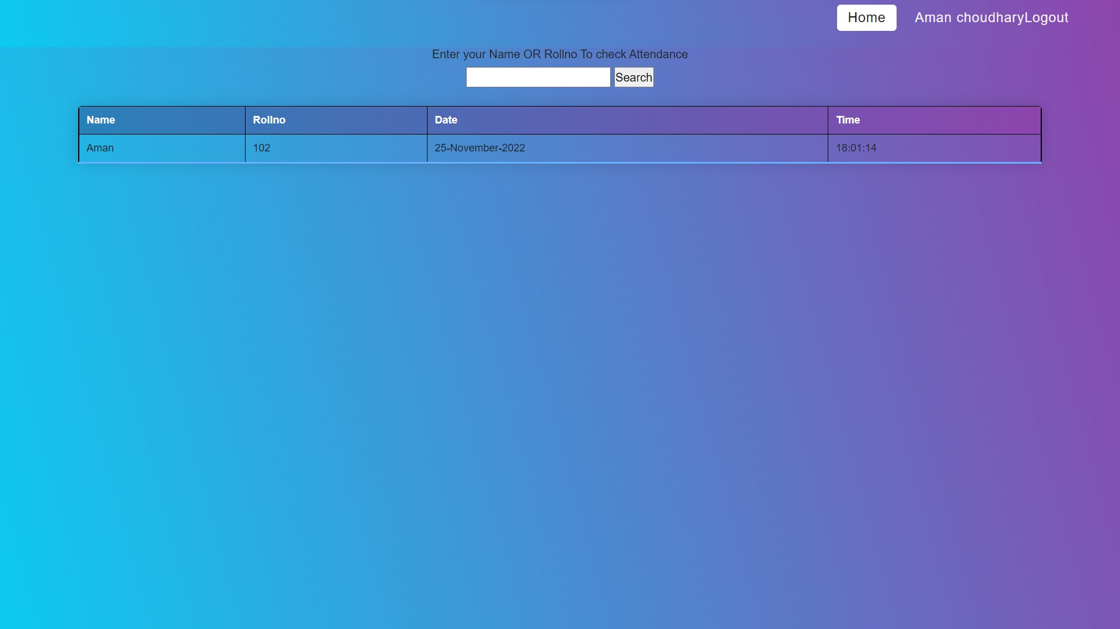

# ADVANTAGES AND LIMITATIONS

## ADVANTAGES :

The system successfully meets the following requirements:

* + Stores and maintains customer information.
  + Can add, update, and delete user information.
  + Can add or remove all things .
  + Easy view of attendance(name , rollno, time, day & dates )
  + Provides limited access to user members.
  + Can add, update and delete admin details.

VALIDATION OF DATA:

* + Invalid data input is prompted using proper message boxes.
  + The data is not stored until it passes the valid data.
  + Incorrect username and passwords are not accessed.
  + Forgotten passwords can be recovered through valid processes.

The system generates all the required reports.

## LIMITATIONS:

* Copyright violation
* Problem with confidentiality.
* It requires further development as per the human requirements.

# FUTURE ENHANCEMENT

The system is designed in such a way that addition of new modules can be done in a very simple and efficient manner. The future holds a lot to offer to the development and refinement of this project. As proper documentation exists the whole system flow is traceable.

Some likely enhancements could be added in the future to enhance the capability of this system.

We may conclude that this software created will definitely find a good market in the FACE RECOGNITION ATTENDANCE SYSTEM to its maximum extend.

# BIBLIOGRAPHY

### WEB REFERENCE :

* [www.google.com](http://www.google.com)
* [www.youtube.com](http://www.youtube.com/)
* [Stack Overflow - Where Developers Learn, Share, & Build Careers](https://stackoverflow.com/)